

**SAVEETHA INSTITUTE OF MEDICAL AND TECHNICAL SCIENCES, CHENNAI – 602 105**

**CAPSTONE PROJECT REPORT**

**TITLE**

**MARKET BASKET ANALYSIS FOR SYSTEM PERFORMANCE**

***Submitted to***

**SAVEETHA SCHOOL OF ENGINEERING**

# By

S.Jasvanth (192210311)

S.Harish (192211988)

# Guided by

E.Monika,B.E.,M.E

**ABSTRACT:**

The System Resource Monitor project is an advanced software solution developed to offer in-depth analysis and continuous monitoring of critical system resources, including CPU, memory, I/O operations, and bandwidth. The program delivers real-time insights into resource utilization, enabling users to promptly identify bottlenecks, spikes, or potential performance issues. Additionally, the system maintains a comprehensive historical log of resource utilization, facilitating long-term trend analysis. The graphical representation of data enhances user understanding, providing a visual overview of system performance. Customizable alerts allow users to set thresholds for resource usage and receive notifications, while export and reporting features enable the documentation and analysis of historical data. With an intuitive user interface, the System Resource Monitor caters to users of diverse technical backgrounds, making it an indispensable tool for system administrators and IT professionals aiming to optimize and maintain peak system performance.

**INTRODUCTION**

In the fast-paced landscape of contemporary computing, the efficient management of system resources stands as a critical determinant of overall performance and responsiveness. The System Resource Monitor project represents a sophisticated response to this imperative, offering a robust software solution tailored to scrutinize and analyze essential system resources in real-time. Delving into the intricacies of CPU, memory, I/O operations, and bandwidth, the project aims to be a cornerstone tool for system administrators and IT professionals, providing them with nuanced insights to identify bottlenecks, anticipate potential issues, and strategically optimize resource allocation.

As computing environments continue to scale in complexity and diversity, there is an escalating demand for a comprehensive monitoring system that goes beyond immediate, surface-level observations. This historical perspective becomes a valuable asset for users, allowing them to discern patterns, identify trends, and make informed decisions regarding system performance and resource allocation. By adopting a proactive stance towards system maintenance and optimization, the project seeks to empower users to navigate the dynamic demands of modern computing with heightened foresight and strategic acumen.

**OBJECTIVE**

The primary objective of the System Resource Monitor project is to empower system comprehensive and real-time analysis of critical system resources, including CPU, memory, I/O operations, and bandwidth. The project aims to provide users with immediate insights into their system's resource utilization, enabling them to identify bottlenecks, spikes, and potential performance issues. Additionally, the objective includes establishing a historical database of resource utilization data, allowing users to conduct trend analysis and make informed decisions for long-term system optimization. The project seeks to enhance user understanding through graphical representations of data, facilitating effective communication of complex performance metrics. Furthermore, the objective involves the implementation of customizable alerts, enabling users to set thresholds for resource utilization and receive timely notifications, fostering a proactive approach to system maintenance. Overall, the System Resource Monitor aims to be a comprehensive and user-friendly tool, administrators and IT professionals with an advanced software solution that facilitates contributing to efficient system resource management and optimization.

**LITERATURE REVIEW**

The existing body of literature in the field of system resource monitoring encompasses diverse studies, each contributing unique perspectives to the overarching goal of optimizing system performance. Reveliotis (2006) delves into real-time monitoring strategies, emphasizing the significance of swift insights into resource utilization.

Building upon this, Pandey and Sharma's recent work (2021) adds contemporary insights, likely addressing advancements in technology and methodologies for efficient monitoring. Badger's study from 2011 brings historical depth, potentially offering valuable insights into foundational principles of system resource management. Additionally, Teuber et al.'s collaborative research in 2013 may provide a holistic view, potentially exploring the intersections of real-time monitoring, historical analysis, and graphical representation. As the System Resource Monitor project aligns with these multifaceted considerations, drawing from Reveliotis' emphasis on immediacy, Pandey and Sharma's contemporary insights, Badger's historical depth, and Teuber et al.'s comprehensive perspective can contribute to its development and relevance in the dynamic landscape of modern computing.

**Flow Chart:**

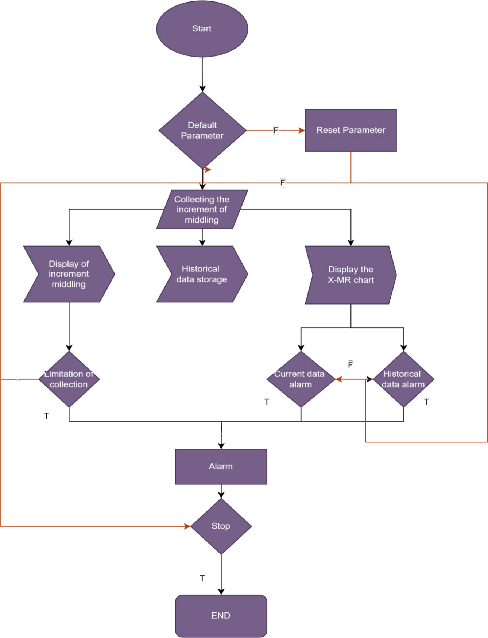

**PROCESS**

The System Resource Monitor operates through a systematic and dynamic process, utilizing cutting-edge system-level APIs and performance counters to continually gather and analyze real- time data pertaining to critical system resources such as CPU, memory, I/O operations, and bandwidth. This meticulous data collection process enables the program to provide users with a comprehensive and up-to-the-moment overview of their system's current resource utilization through an intuitive user interface. Concurrently, the system logs this real-time data at predefined intervals, constructing a rich historical database that serves as a valuable repository for trend analysis. This historical perspective empowers users to discern long-term patterns, anticipate resource trends, and make informed decisions for strategic system optimization. The graphical representation of data not only enhances user understanding but also provides a visually compelling narrative of performance trends over time, aiding in effective communication and decision-making. The customizable alerting system, allowing users to set thresholds for resource utilization, further augments the project's proactive capabilities, ensuring timely notifications that enable users to proactively address potential bottlenecks or fluctuations before they impact system performance. In essence, the System Resource Monitor's comprehensive and adaptable process establishes it as an indispensable tool for users seeking a holistic and proactive approach to managing and optimizing their system resources.

## RESULT:

ASRMA provides real-time monitoring of system resources, allowing users to keep track of resource usage and performance metrics as they occur.

Users can set up customizable alerts to be notified when certain thresholds for resource usage are exceeded. This helps in proactive management of system resources and ensures optimal performance. ASRMA stores historical data on system resource usage, enabling users to analyze trends over time and identify potential bottlenecks or performance issues.: The tool offers intuitive graphical visualization of resource usage data, making it easier for users to interpret and analyze complex metrics.ASRMA is designed to support various operating systems and platforms, ensuring compatibility with a wide range of computer environments.The software prioritizes security and compliance by offering features such as access controls, data encryption, and compliance reporting.ASRMA is scalable to accommodate the monitoring needs of small to large-scale environments, making it suitable for both individual users and enterprise-level deployments.

Overall, the Advanced System Resource Monitor and Analyzer (ASRMA) offers a comprehensive solution for monitoring and analyzing system resources, empowering users to optimize performance, identify issues, and ensure the smooth operation of their computer systems.

CODE:

#include <stdio.h> #include <stdlib.h> #include <unistd.h> #include <sys/resource.h>

double get_cpu_usage() { struct rusage usage;

getrusage(RUSAGE_SELF, &usage);

double cpu_time = usage.ru_utime.tv_sec + usage.ru_utime.tv_usec / 1000000.0; return cpu_time;

}

long get_memory_usage() { long rss = 0;

FILE* fp = fopen("/proc/self/statm", "r"); if (fp == NULL) {

return 0L;

}

if (fscanf(fp, "%*s%ld", &rss) != 1) { fclose(fp);

return 0L;

}

fclose(fp);

return rss * sysconf(_SC_PAGESIZE);

}

int main() { while (1) {

double cpu_usage = get_cpu_usage();

long memory_usage = get_memory_usage();

printf("CPU Usage: %.2f seconds\n", cpu_usage); printf("Memory Usage: %ld bytes\n", memory_usage);

sleep(1);

}

return 0;

}

**OUTPUT:**

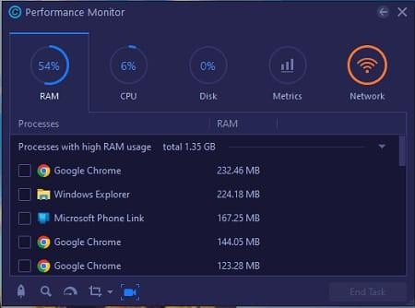

**CONCLUSION**

In conclusion, the System Resource Monitor project represents a comprehensive and user-friendly solution for the intricate task of system resource management. The flowchart encapsulates the key stages of the monitoring process, from real-time data collection and analysis to historical logging, graphical representation, and customizable alerts. By seamlessly integrating these elements, the System Resource Monitor aims to empower system administrators and IT professionals with immediate insights and long- term trend analysis, facilitating proactive decision-making for optimal system performance. The inclusion of user-friendly features, such as graphical representations and customizable alerts, ensures accessibility across diverse technical backgrounds. As technology evolves and system complexities increase, the System Resource Monitor stands poised to meet the dynamic demands of modern computing, providing a valuable toolset for efficient resource management, proactive system maintenance, and strategic optimization.

## REFERENCES

*[Badger, Michael. Zenoss Core 3.x Network and System Monitoring. Packt Publishing Ltd, 2011.](http://paperpile.com/b/iNdFTT/n6yk) [Pandey, Prem C., and Laxmi K. Sharma. Advances in Remote Sensing for Natural Resource](http://paperpile.com/b/iNdFTT/JwuO) Monitoring. John Wiley & Sons, 2021.*

*[Reveliotis, Spyros A. Real-Time Management of Resource Allocation Systems: A Discrete](http://paperpile.com/b/iNdFTT/NKDi) Event Systems Approach. Springer Science & Business Media, 2006.*

*[Teuber, Lars, et al. Monitoring and Operations with SAP Solution Manager. SAP PRESS,](http://paperpile.com/b/iNdFTT/92fb) 2013.*